 **1 Aug 2014** **The Weekly Bulletin of Rotary Club of Kathmandu Mid-Town** **bc-05/8.014**

|  |
| --- |
|  |

District: 3292 Web:www.rotarymidtown.org.np Club Id: 26776

**AUGUST IS MEMBERSHIP & EXTENSION MONH**

**Celebrating**

**25 Years in Rotary**





Friday, 25 July :

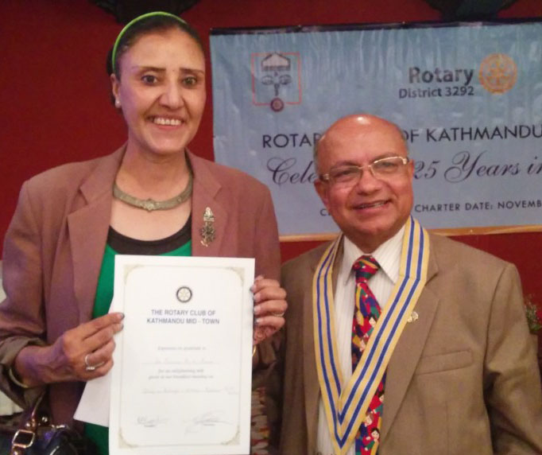

Ms Poonam Rana was our guest speaker.

She was introduced by Rtn Bhairaja Panday. She spoke on 'Witch

Practice in Nepal: Study on Beliefs, Witches (Bokshis) and Faith

Healers, Believe it or Not.'

The presentation was followed by interaction with Club members.

President Kul with Guest speaker Poonam after handing over a >>

certificate of appreciation to her.

The women who were worshipped as the incarnation of goddess in the ancient eras are now facing different sorts of violence. Violence occurred in their life in different ways such as social, political, economic, sexual violence and so on. Each and every day the media reports stories of violence against women in our society. This violence manifests itself in different forms such as abuse, rapes, sexual harassment in the work place, domestic violence (marital rapes, physical and mental tortures), trafficking of girls or women for sexual and labor exploitation .etc. Forms of violence against the women are the outcome of discrimination due to patriarchal attitudes and deep-rooted stereotype such as the determination of harmful traditional practices such as witchcrafts, early marriage, dowry system, polygamy, Chaupadi, Jhuma, Deuki, Dhan khane, Ghumto pratha etc.

A lot of Nepalese women fall victim to accusations of witchcraft and are tortured despite the fact that the accusations are based on superstition. Belief in witchcrafts has prevailed in the underdeveloped and developing countries since ancient times and it is always women who are considered as the practitioner with supernatural powers (i.e. the negative energy that can hepatize the man, animals and other living things and responsible for making them ill or even killing them). It is the result of religious practices and the mentality of the society that it is the women who are always accused. Despite the arrival of the 21st century, the community views towards women has not changed yet and still they are vulnerable to being accused of practicing witchcraft and being tortured by members of their own community. Mostly widows and the elderly with low economic status, especially those who belonged to so called lower caste of Dalits and other marginalized communities are accused of witchcraft. Some people in the Nepalese society continue to believe that the magical powers of these women are responsible for the infirmity of the people.

Women accused of witchcraft are severely traumatized and suffer physical and mental torture. They suffer greatly through being ostracized from the society, battered, fed human excreta, hit with hot spoons in different parts of the body, forced to touch red hot irons, forced to breathe in chili smoke, especially by Jhankris (the witch-doctors), perforated in private organs, offended publicly and it is therefore not surprising that they confess. The deep traumatic impact of such experience cannot only be seen in the lives of the women who are accused of being witches but also felt by their families who pay for that. Often, all the family members are tortured or they are compelled to leave their homes as well as the areas in which they have been residing for many years. The victims lose their self respect in their family and society as well. Some of them are even rejected by their family and their lives become more complex day by day as they are reluctant to return to their own village since the violence they endured is still fresh in their memory with mental and physical disorders. Even if they returned to their society, the insult and torture that they faced will never let them return to normalcy and some of them even commit suicide as it is difficult for them to return to their family and society with the possibility of such an immense accusation being laid yet again.

<><><><><><><><><><><><><><><><><><><><><><><><><><><><><><><><><><><><><><><><

Pres Kul Chandra presented Paul Harris Fellow pin and certificate to Sangita Shrestha Einhouse

(daughter of PP Ambica) and to PP Ambica for her grandson Rene Vijay Einhouse.

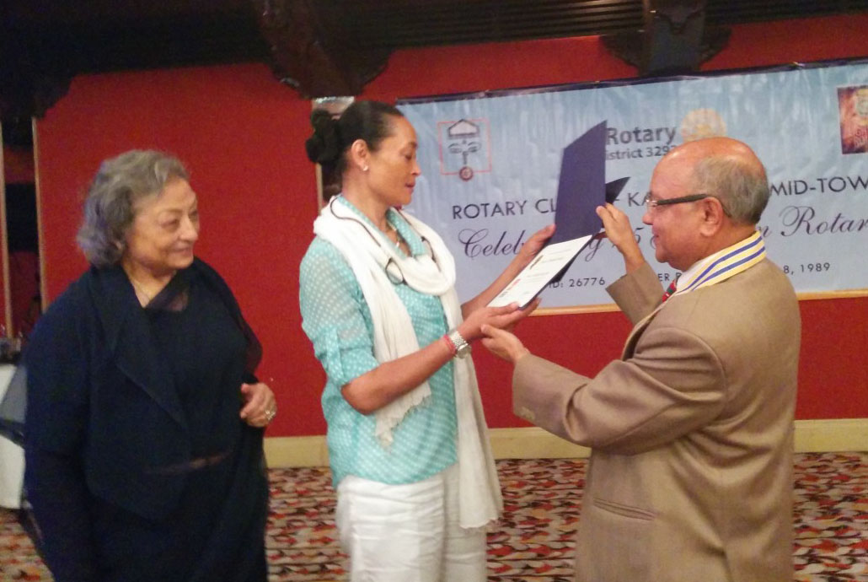

Information sharing:

- The *Spouses' Group* led by Ms Sunita Joshi is going to donate two hospital beds to the newly formed children's unit at Bhaktapur Cancer Hospital. The beds are named after their late friends Kay (Clawson) and Mala (Golchha).The handing over program is scheduled on Monday, 28 July 2014 at Bhaktapur Cancer Hospital.

- Guest Rotarian DGN Jaya Shah informed that she had recently attended a DGN meeting in Mumbai on membership increase and retention. It was emphasized that membership growth in Rotary clubs in Nepal should be about 20 % during the year.

- PP Mani informed (a) on RI Zonal Membership awards 2014-15. RI Zonal membership awards have been instituted to recognize the Rotary clubs, best performing president, and individual Rotarians of each Rotary District under Zone 6A in different categories during the year, and (b) that the Rotary Peace Scholar, Rubina Mahato, has now completed her study and has been accepted into a PhD program at Oxford University, UK.

Eid-Ul-Fitr: 29 July

Eid-ul-Fitr is a unique festival. It has no connection with any historical event nor is

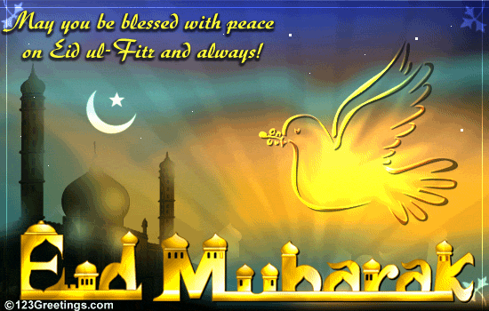

it related to the changes of seasons or cycles of agriculture. It is not a festival

related in any way to worldly affairs.

Its significance is purely spiritual. It is the day when the Muslims thank Allah for

having given them the will, the strength and the endurance to observe fast and

obey His commandment during the holy month of Ramadhan.

This day, in Muslim world, brings rejoicing and happiness. The rejoicing is not, however, at the departure of the month of Ramadhan; it is the happiness which man feels after successfully completing an important task.

On this day, special prayers are held the world over, between sunrise and noon, when the Muslims assemble, in large congregations, wearing their best dresses standing shoulder to shoulder, demonstrating for everyone the universal brotherhood which is another distinguishing feature of Islam - the religion of God.

# Weekly Meetings and Programs :

|  |  |  |
| --- | --- | --- |
| Date | Program/Speaker | Program/Topics of Presentation |
| 1 Aug 2014 | Sheri Meyerhoffer | ?? |
|  |  |  |
|  |  |  |

Friday, 1 August :



Sheri Meyerhoffer holds a Bachelor of Arts in Political Science (Hon. '82) and a Juris

Doctor ('85). She is a Canadian lawyer with technical expertise in the areas of law

reform, governance and capacity building developed over more than two decades

through hands on experience with writing, interpreting, and advocating for legislative

and regulatory law reform in Canada, Russia, Cuba, China, Jamaica, and Nepal.

She worked (2007-2009) for the CBA in Nepal on a Canadian International Development

called Developing Democracy in Nepal. When the Nepal Bar Association released a report in 2009 on the promotion of women in the legal profession (Ringing the Equality Bell: The Role of Women Lawyers in Promoting Gender Equality in Nepal), Sheri was struck by the significant barriers and challenges facing women in law in Nepal. The seed was planted that would lead her to co-found Women Lawyers Joining Hands, a not-for-profit organization that addresses the issues faced by women lawyers in Nepal by providing education and training.

On Lighter Side :

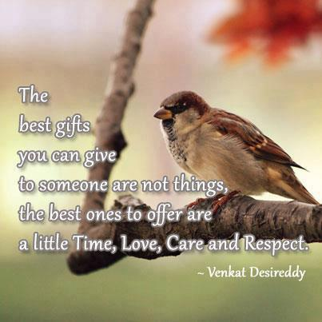



Great quotes :

**There is a sacredness in tears.**

**They are not the mark of weakness, but of power.**

**They speak more eloquently than ten thousand tongues.**

**They are messengers of overwhelming grief...and unspeakable love.**



I want to see a Rotary that is brighter, with a light that shines out clear and strong. I want our

light to be warm and inviting so that other people want to come closer, to be a part. I want this

light to inspire, to show everyone what one person can do, what we can all do when we work

together.

**RI President GARY C.K. HUANG**

Please send information on club activities, progress reviews on service projects, relevant photos etc to:

BC Editor: RR Shrestha email: rryesrr@gmail.com

## 1 August 2014 The Weekly Bulletin of Rotary Club of Kathmandu Mid-Town bc-05/8.014